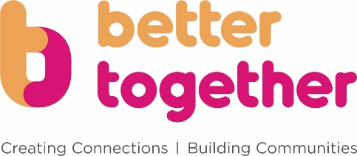
Better Together
Eligibility Checklist and Referral Form

Better Together is targeted at people whose loneliness and social isolation is the PRIMARY factor affecting their mental and physical health and wellbeing.
We can offer support to help people get out more and become more involved with their activities in their community.
Use this form to check whether the person is suitable for the Better Together service and to make a referral.
About the person you wish to refer
 | Yes | No
Is the person you wish to refer lonely or social isolated?

Is their loneliness and social isolation having a negative impact on their physical or mental health and wellbeing?

Are they willing to get out more and take part in activities?

Are they physically able, with support if necessary, to get out more and take part in activities?

Are they likely to benefit from getting out more and taking part in their community?

Does the person know they are being referred for support from the Better Together team?
You must answer yes to all of the above for us to progress this referral

Please note, if the person you wish to refer meets any of the following criteria, they MAY not be suitable for this service without greater consent and information being gained.

· Currently receiving support from the crisis team
· Exhibiting or has a history of sexual violence or thoughts of sexual violence
· A threat to others
· Currently having suicidal or homicidal thoughts
· Currently using weapons or has used weapons in the past 12 months
· Is exhibiting signs of radicalisation
· A person or a parent of someone subject to a full care order

What specific outcomes would you like your client to work with Better Together to achieve? Tick all that apply.
(We will work with your client to form a joint support plan to enable them to achieve these outcomes)
 | Yes | No
Meet new people
Re-kindle a hobby or interest
Increase in confidence
Contribute their skills and experience
Access community assets/services
Move into volunteering
They need information, advice and guidance (IAG) in the following area(s) to enable them to take part
Transport, travel and mobility
Health
Caring responsibilities
Finance, benefits and money
Other Support (Please state)

Referral Information
About the person you wish to refer
First Name

Last Name

Address

Village or Town

Postcode

Mobile phone number

Home Telephone No.

Email Address

Date of Birth

Tell us more about their situation

How would they like us to contact them? | Mobile phone  Home phone  Email
Is there a preferred time for us to contact them? Please note the Better Together service operates Monday to Friday 9am-5pm
Does this person have any additional needs?

Are there any risks associated with this person?
(Please attach any formal Risk Assessments)

About you (as the professional making the Referral)
First Name

Last Name

Job Title

Which organisation do you work for?

Which department (if applicable)

You mobile number

Your work telephone number

Email address

Please note, we cannot progress this referral without your contact details

Please email this form to info@bettertogethernorfolk.org.uk. We will then contact the person directly within 10 working days.
Better Together is part of a county-wide initiative funded by Norfolk County Council to help tackle loneliness and social isolation. We deliver services and support in South Norfolk, parts of Breckland, Greater Norwich and Great Yarmouth. Better Together is a partnership led by Voluntary Norfolk together with Access Community Trust, Opening Doors, KindaKafe (The Missing Kind), St Martins Housing Trust, Home-Start Norfolk, Harleston Information Plus, Centre 81, Feedback Mental Health, Independence Matters and Carers Voice. www.bettertogethernorfolk.org.uk

